**Basic Administration**

**Duties of System Admin**

1. **Controlling Access**

The system admin creates accounts for new users, removes the account or inactive users and also handles all account related issues.

1. **Adding** **Hardwares**

The system admin adds storage devices and configures it so that the operating system can recognize them.

1. **Automating Tasks**

The system admin uses tools to automate repetitive and time consuming tasks as it has less probability of error (human errors).

1. **Backups**

The system admin regularly performs backup and restores data.

1. **Installing and Upgrading Softwares**

The system admin installs and configures the softwares essential for system working and at times when a piece of software is not necessary the admin removes them from the system. He/She also upgrades those softwares to fix vulnerabilities and reduce the attack surface.

1. **Troubleshooting**

The system admin fixes the unexpected network failures and problems that occur in the system.

1. **Maintaining Local Documents**

The system admin chooses the vendors, writes scripts, deploy softwares and makes other decisions related to the system. Moreover, making diagrammatic documents to improve its readability.

1. **Monitoring Security**

The system admin is responsible for maintaining security, they make security policies and set up procedures to protect the system.

1. **Tuning Performance**

The system admin configures the system to achieve optimal performance.

**Sections of Man Pages**

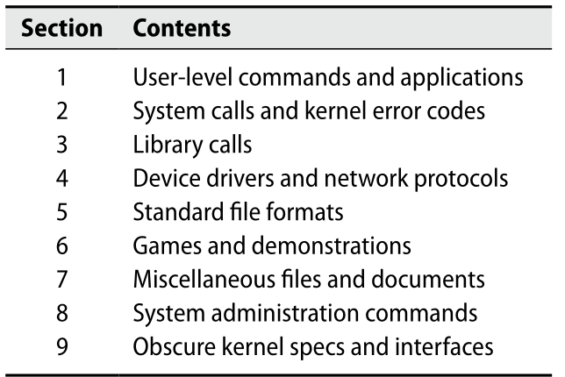

**OS Vendor Documentation**

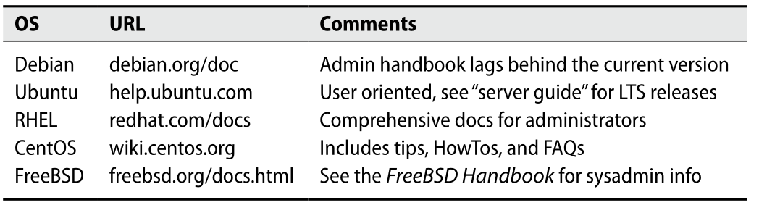

**Resources for keeping up to date**

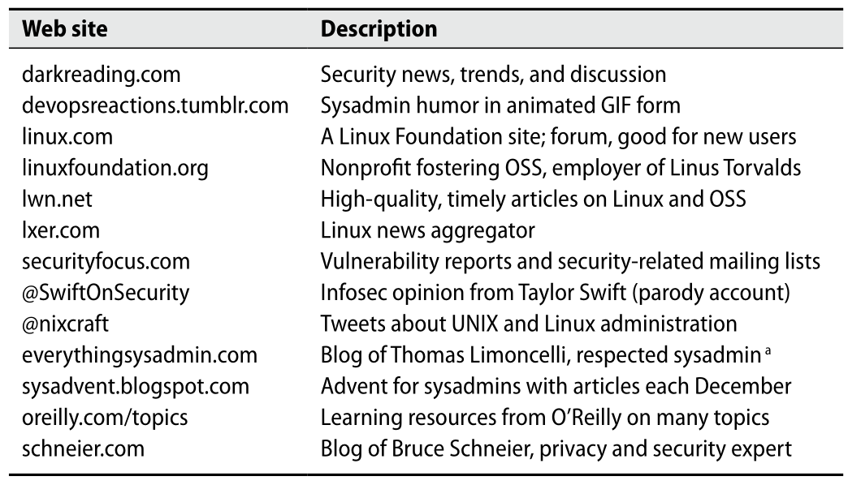

**Task-specific forums and reference sites**

